**Tableau for Good – The Battle for Land**

Selchuk Emin, Erik Polano, Marc Montanari, Archana Ganeshalingam and Paulien Smeele

**COLLECTING AND ENRICHING DATA**

* We used the land grabbing data from the Land Matrix as our basis: <https://landmatrix.org/en/>
* We used Geo Coding to parse out the specific location of land grabbing occurrence  from the free text: <https://gist.github.com/marcomix54/cabe15f4f3a21e9d832cdd47c047d66e>
* We enriched this data with conflict data per location, taken from Acled Data: <https://www.acleddata.com/>

**CLEANING AND RESTRUCTURING DATA**

* We used Tableau Prep to clean the Land Matrix excel files. Download here: <https://tableau.egnyte.com/fl/MdWEIWH5LN>

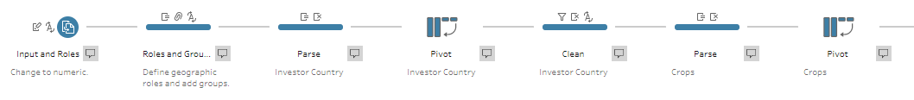

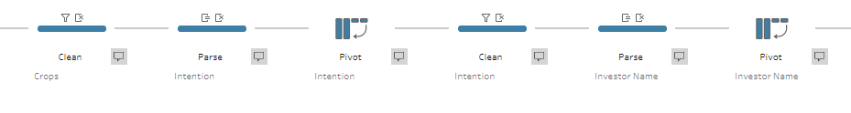

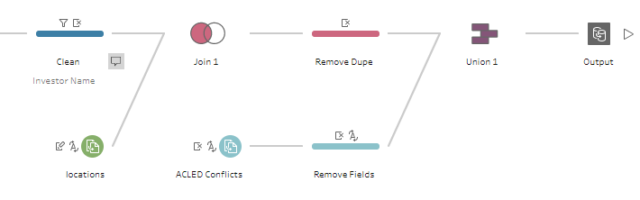

* Scalability of solution: all these steps can be replicated using the python library pandas or knime. See the descriptions of each cleaning step for instructions.
* Future goals: As part of this solution we would encourage a framework to be set up for the collection of data on the ground (e.g. a simple survey form), to avoid the need for data preparation and increase reliability.

**VISUAL APPLICATION**

* We built out visual application using Tableau Desktop, a visual analytics software installed locally on our laptops. Should anyone want to make adjustments to the visualizations, they can install the Public Tableau Desktop version here for free: <https://public.tableau.com/en-us/s/>
* We published the applications up to Tableau Public, which is a free platform used by data journalist, NGOs and members of the Tableau community to share visualizations and dashboards. Find the visual application here: <https://public.tableau.com/profile/selchuk.emin#!/vizhome/TheBattleforLand/LandMatrixOverview?publish=yes>
* Scalability of solution: the data in the visual application will update as the data changes, making sure that decisions are made with up-to-date data.
* Future goals:In order to predict future land grabbing, additional factors can be added to provide a prediction model to the higher stakeholders (e.g. distance to water supply, potential land fertility).